Please remember that while the TeamSnap Mobile app can be used for almost all functionality at the ‘Team’ level – Commissioner functions (other than Messages) can only be done when logged in through a browser.
The backend Commissioner functionality in TeamSnap has gone through an overhaul since all of you used the tool last year to run your respective Divisions within the Rec Program. I will be doing a Google Meet (or Zoom) session in the next couple of weeks (recorded for those unable to attend) to walk through the new navigation in preparation for the season ahead. However, in the meantime I am providing some basic guidance in the screenshots below that would allow you to see what the current state of registrations in your Division looks like.
The first major change is that having Commissioner level access requires that you ‘accept’ an invitation similar to the one below in order to be add as member of the HBC ‘Staff’. This step is necessary even if you already have a TeamSnap account associated with your current email address. You would have received an invite like this one a few weeks back, but the invite does expire after some period of time. I will be resending to all who show as ‘Pending’ on my end until I see that everyone has actually accepted. You will not be able to proceed through any of the follow-on steps captured in this document until you have accepted this email invite by clicking on the green ‘Accept Organization Invite’ button to launch into the new UI.
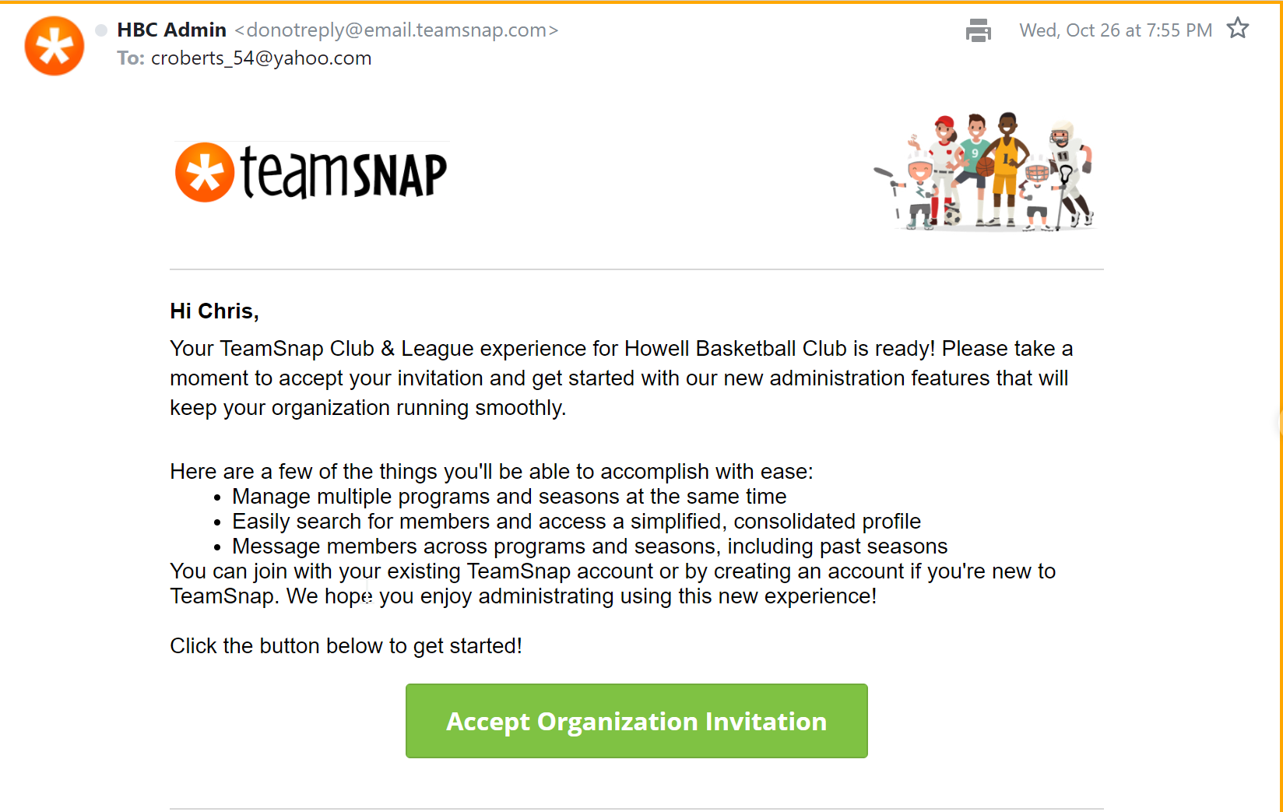

Clicking on the green button should bring you to a screen like the one below where you see the ‘HBC Recreation and Instructional Program’ link that you should click on to navigate forward.
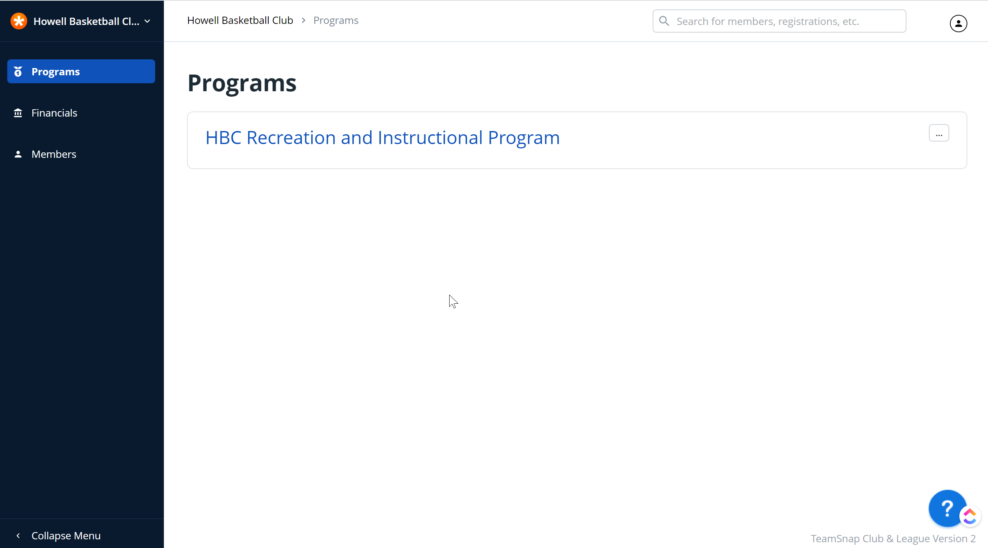

The other significant change is in the hierarchy of the organization structure around which data is managed within TeamSnap.
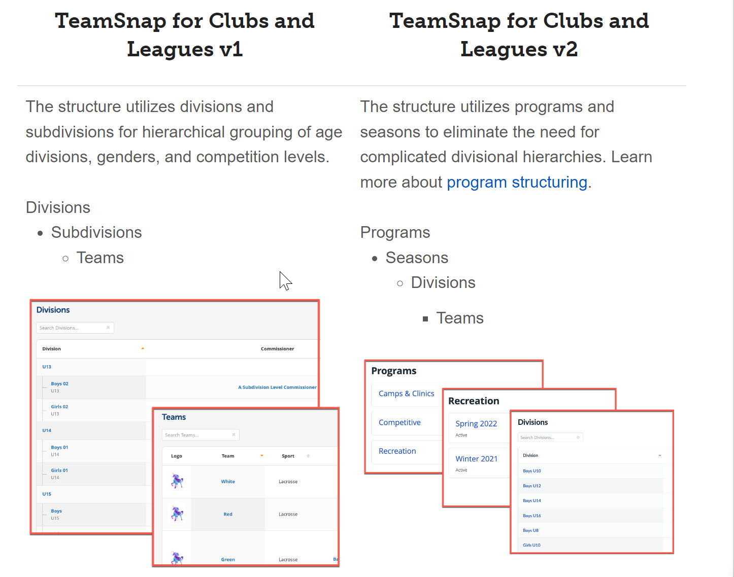

Within a ‘Program’ there are now individual ‘Seasons’ where the actual Divisions/Teams/Players exist for the 2022-23 Season. Click on that link to then drop into the active ‘Season’.
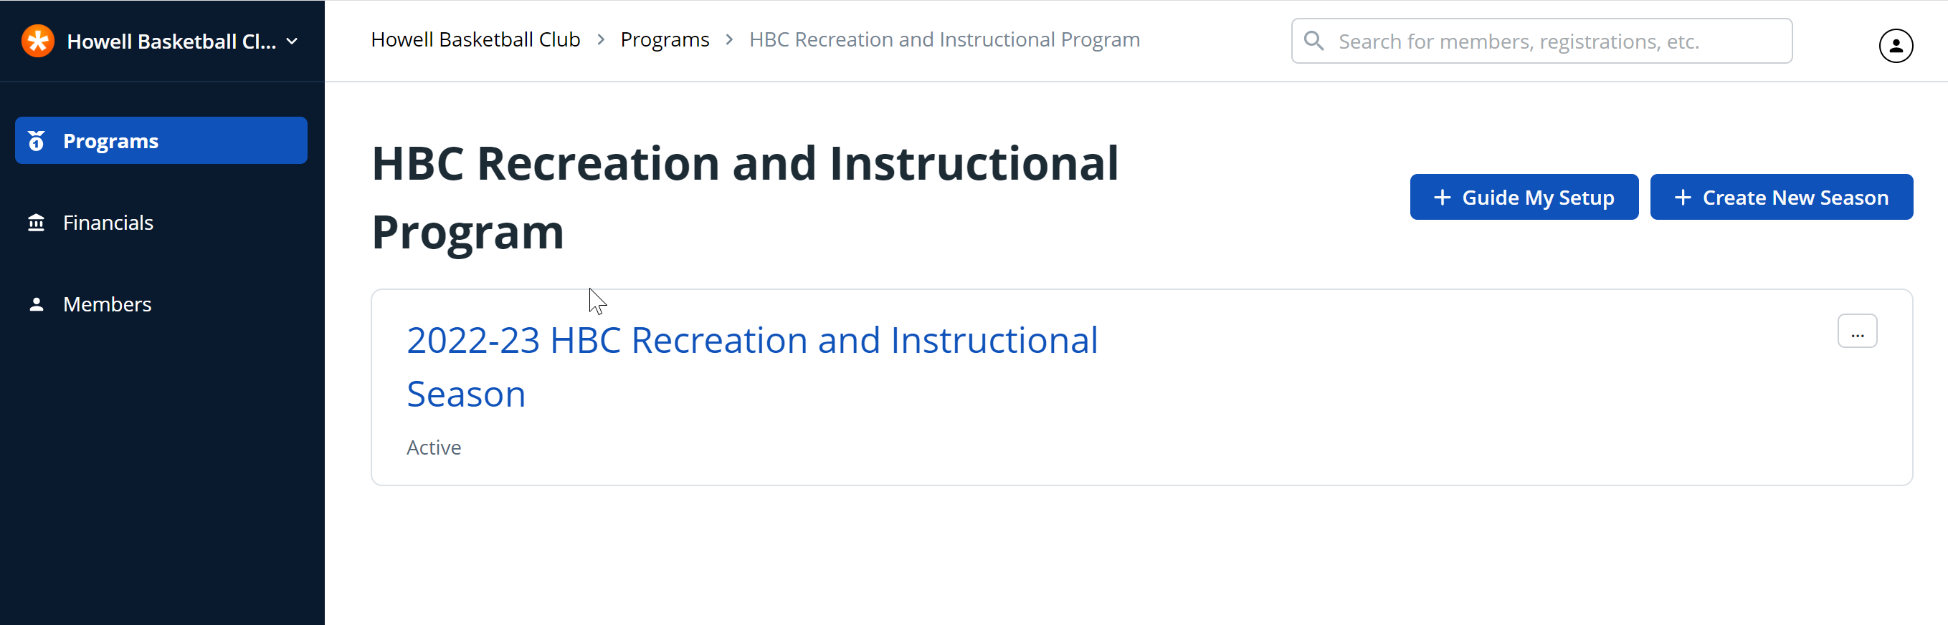

Once in the 2022-23 Season, you will notice that unlike in the previous UI where you could only see your Division and the players within it, as a member of the ‘HBC Staff’, you can now see all Divisions and all Players. This is not ideal as it makes it a little easier to accidentally make changes to someone else’s Teams/Rosters, so from here on you do need to be certain that you are setting the correct ‘Division’ context before you make changes.
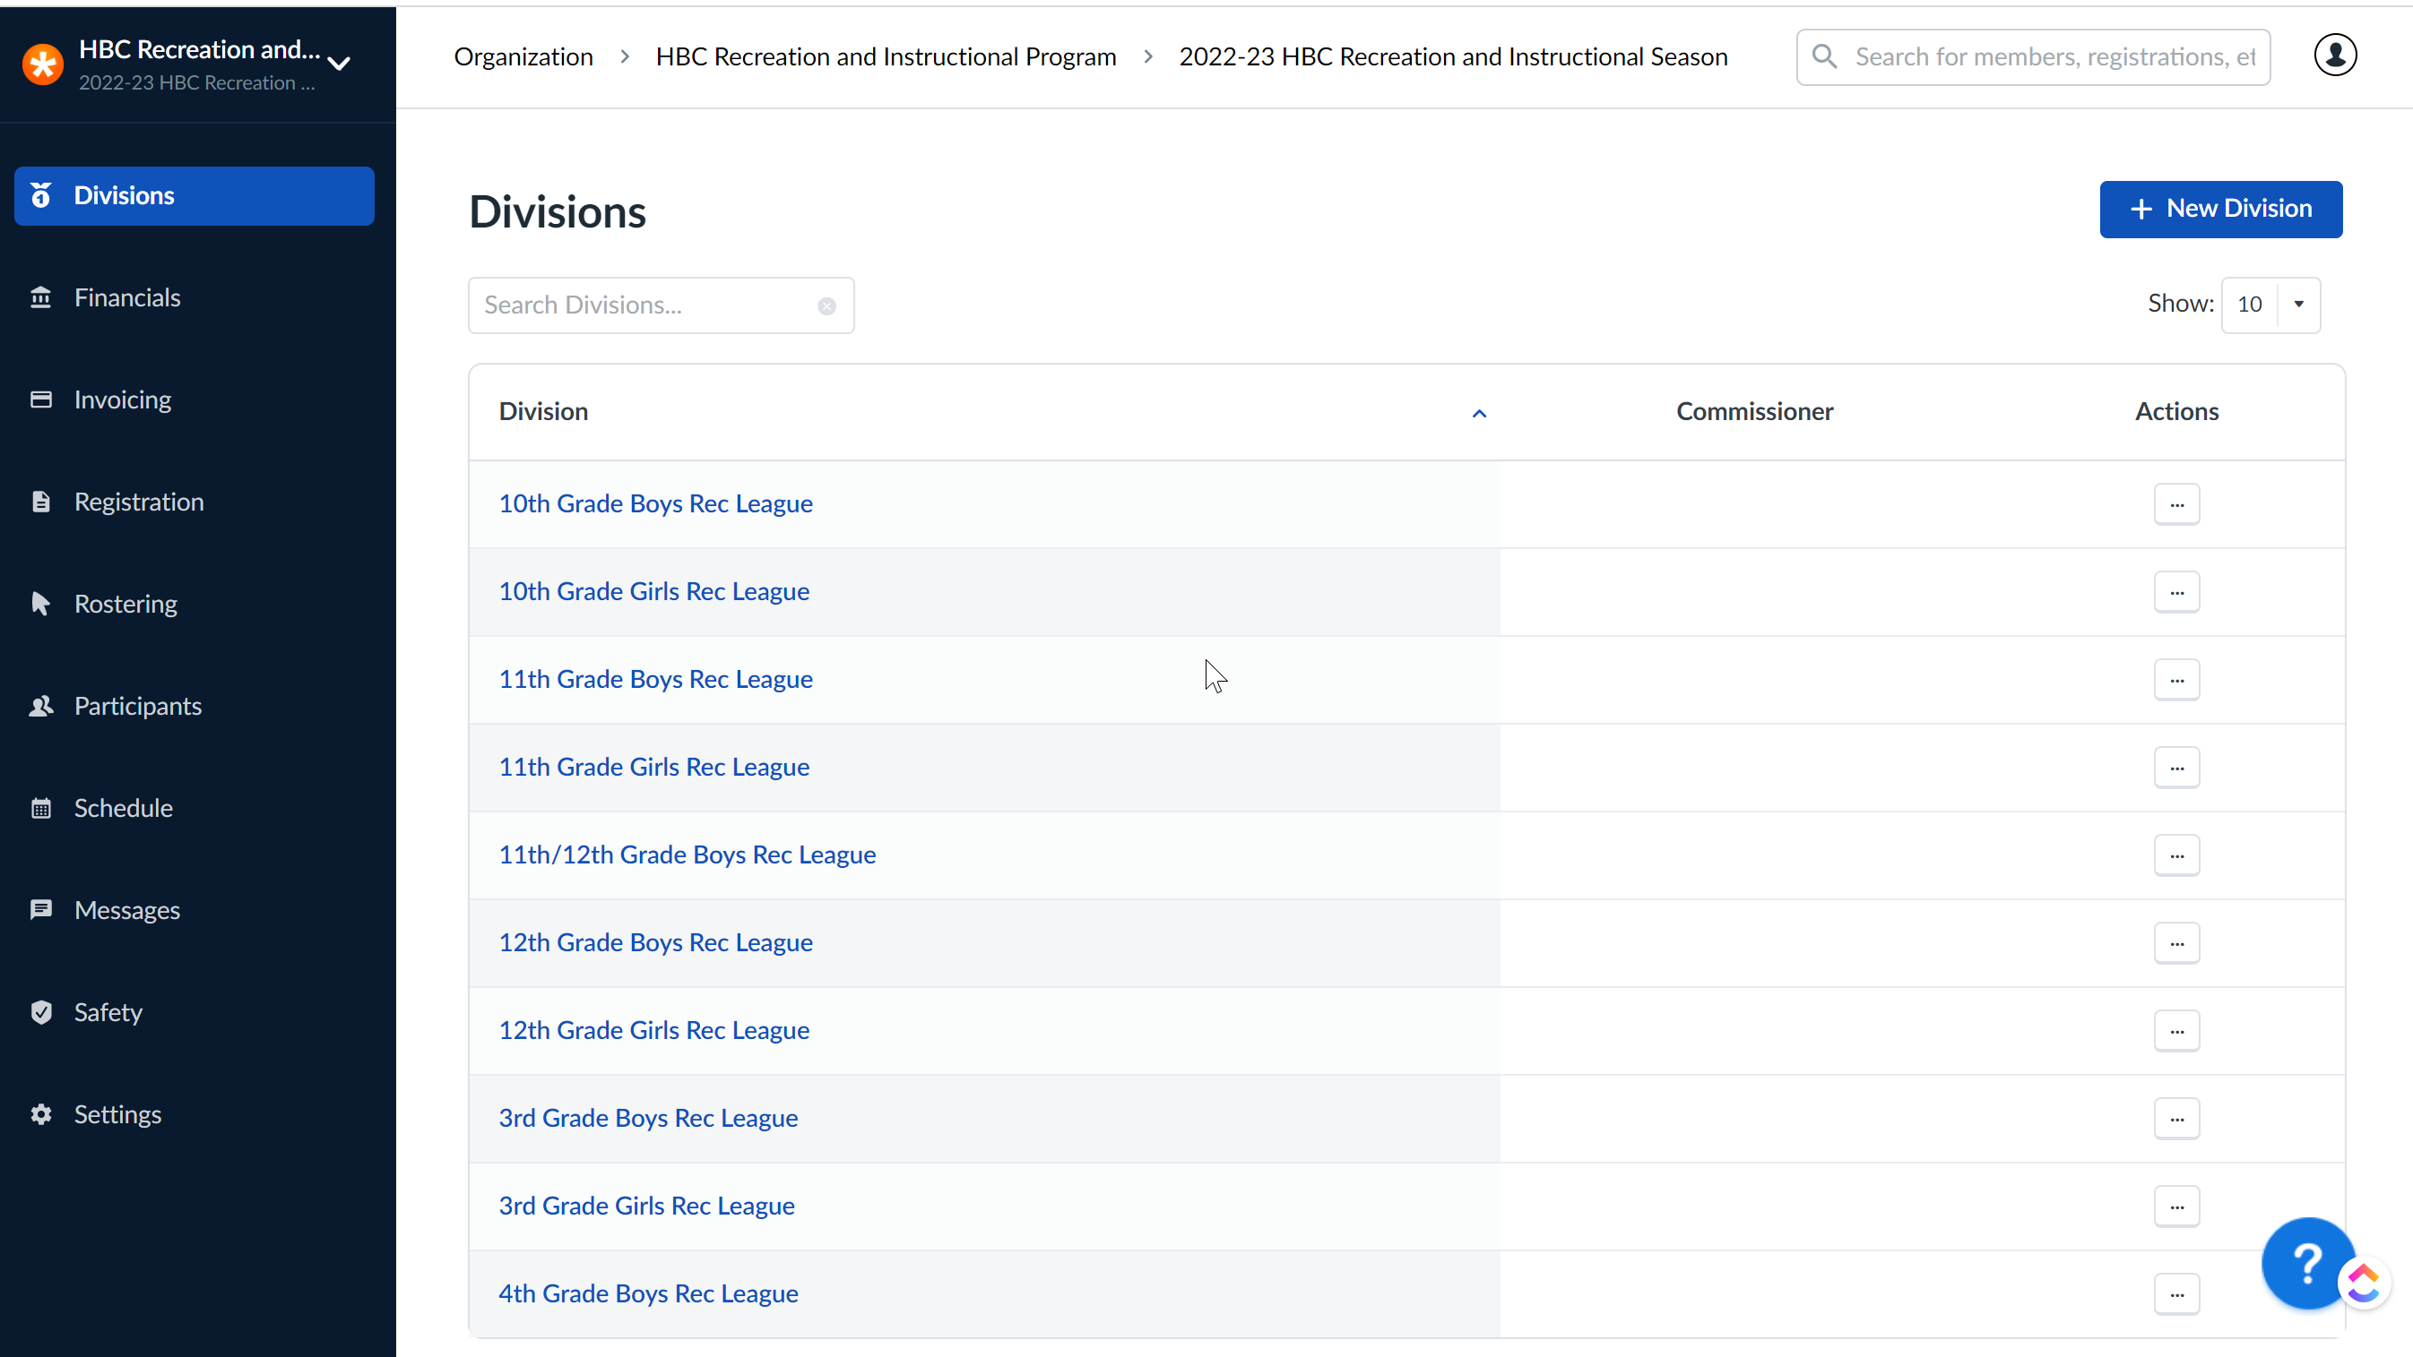

I have specifically clicked in the ‘3rd Grade Boys Rec League’ to get to the screen below where I see a listing of teams within this particular Division. I have now successfully set the context for the teams and players I see to only that Division.
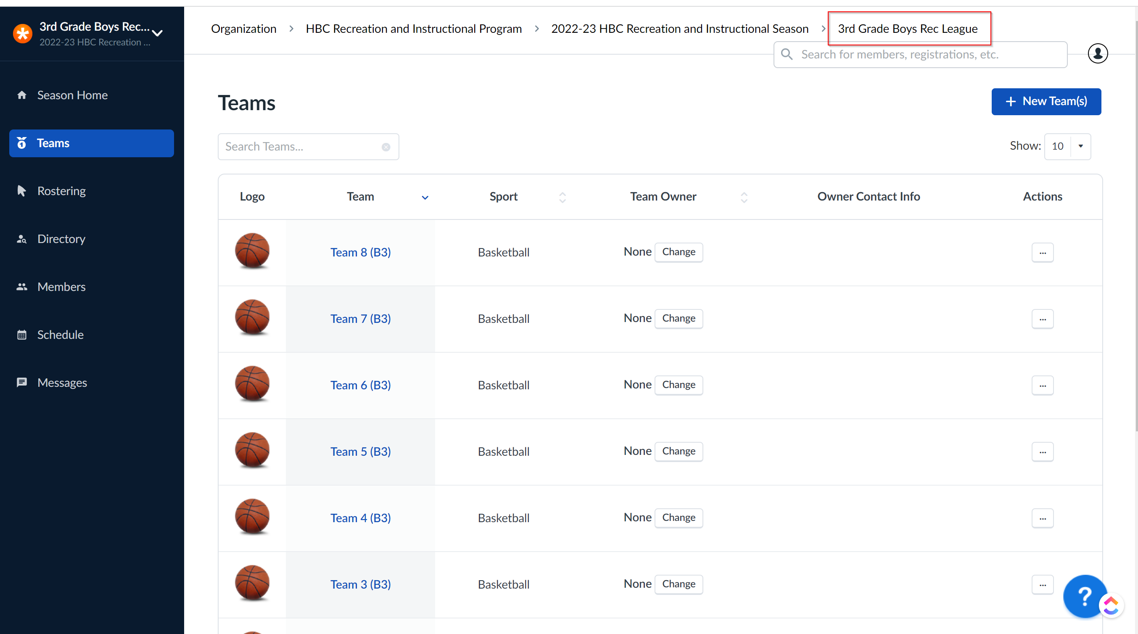
If you then click on the ‘Rostering’ title in the left hand column you will navigate to a screen that you may recognize from the past. The functionality within the ‘Rostering’ tab at this point is very similar to what you are familiar with from past seasons. When you first arrive on this screen, there will be no players in the left column, but you will see team names in the right column.
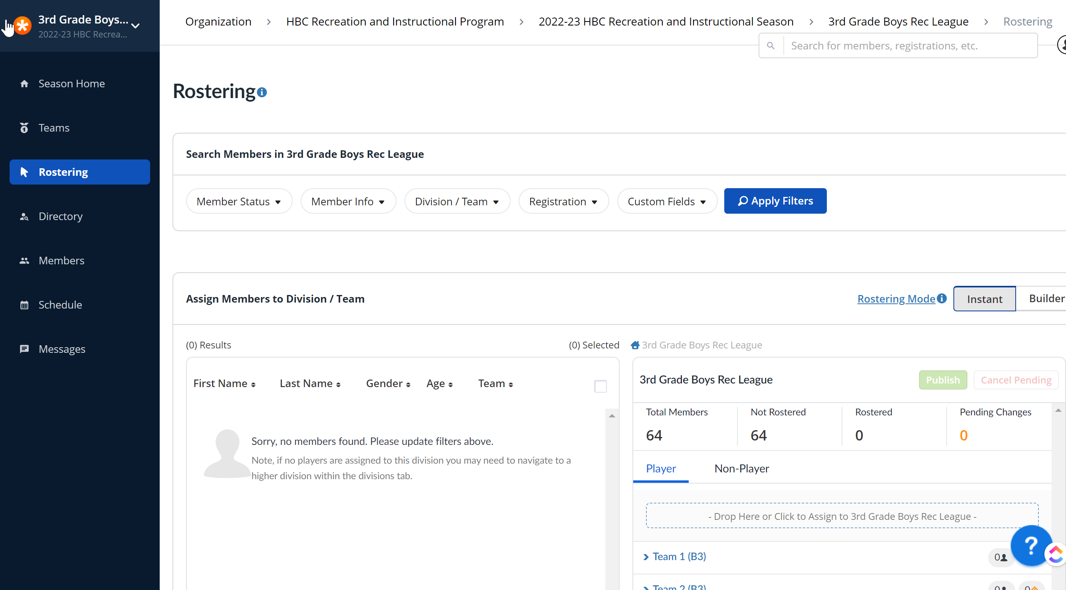
You don’t actually need to select any parameters in the ‘Filter’ settings across the top since we are already in the context of the ‘3rd Grade Boys Rec League’ in this case. You can just click on the ‘Apply Filters’ tab and you will see all currently registered players now in the left column all with a total number of players at the top of that list (64 Results in this case). You can feel free to browse that list as needed.
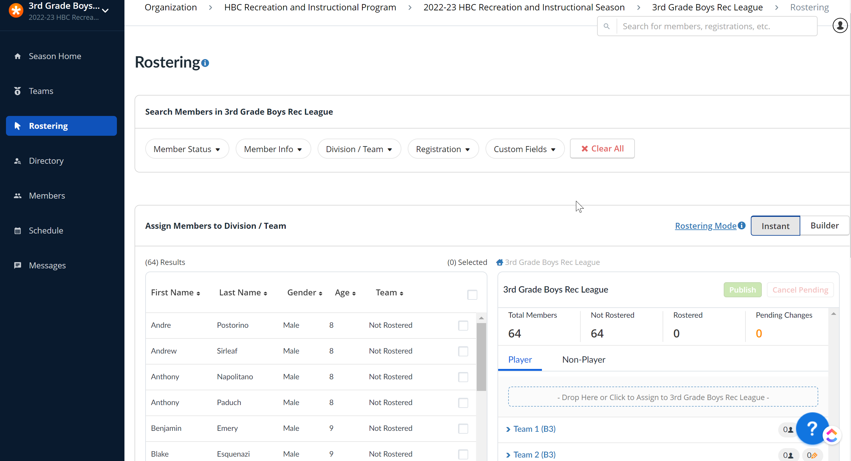
At a later time after the close of registration, you will use this same ‘Rostering’ tab to drag/drop registered players from the left column over to the appropriate ‘Team in the right column to build out your Team Rosters. Remember that the ‘Rostering Mode’ setting just above the right column offers you the options of ‘Instant’ and ‘Builder’ modes.
- ‘Instant’ means that as soon as you move a player to a team, that Player would be able to see their Team assignment if they happen to be looking in TeamSnap at any point – the change takes immediate effect.
- ‘Builder’ means that you can drag/drop Players to teams and move them around behind the scenes where nobody sees those changes until you ‘Publish’ the Roster at some later time.

Step 1: Make sure that you have the correct number of ‘Teams’ within your ‘Division’. Add/Remove additional teams as needed.
Reference Link: Add a Sports Organization Team

Click the ‘New Teams’ button
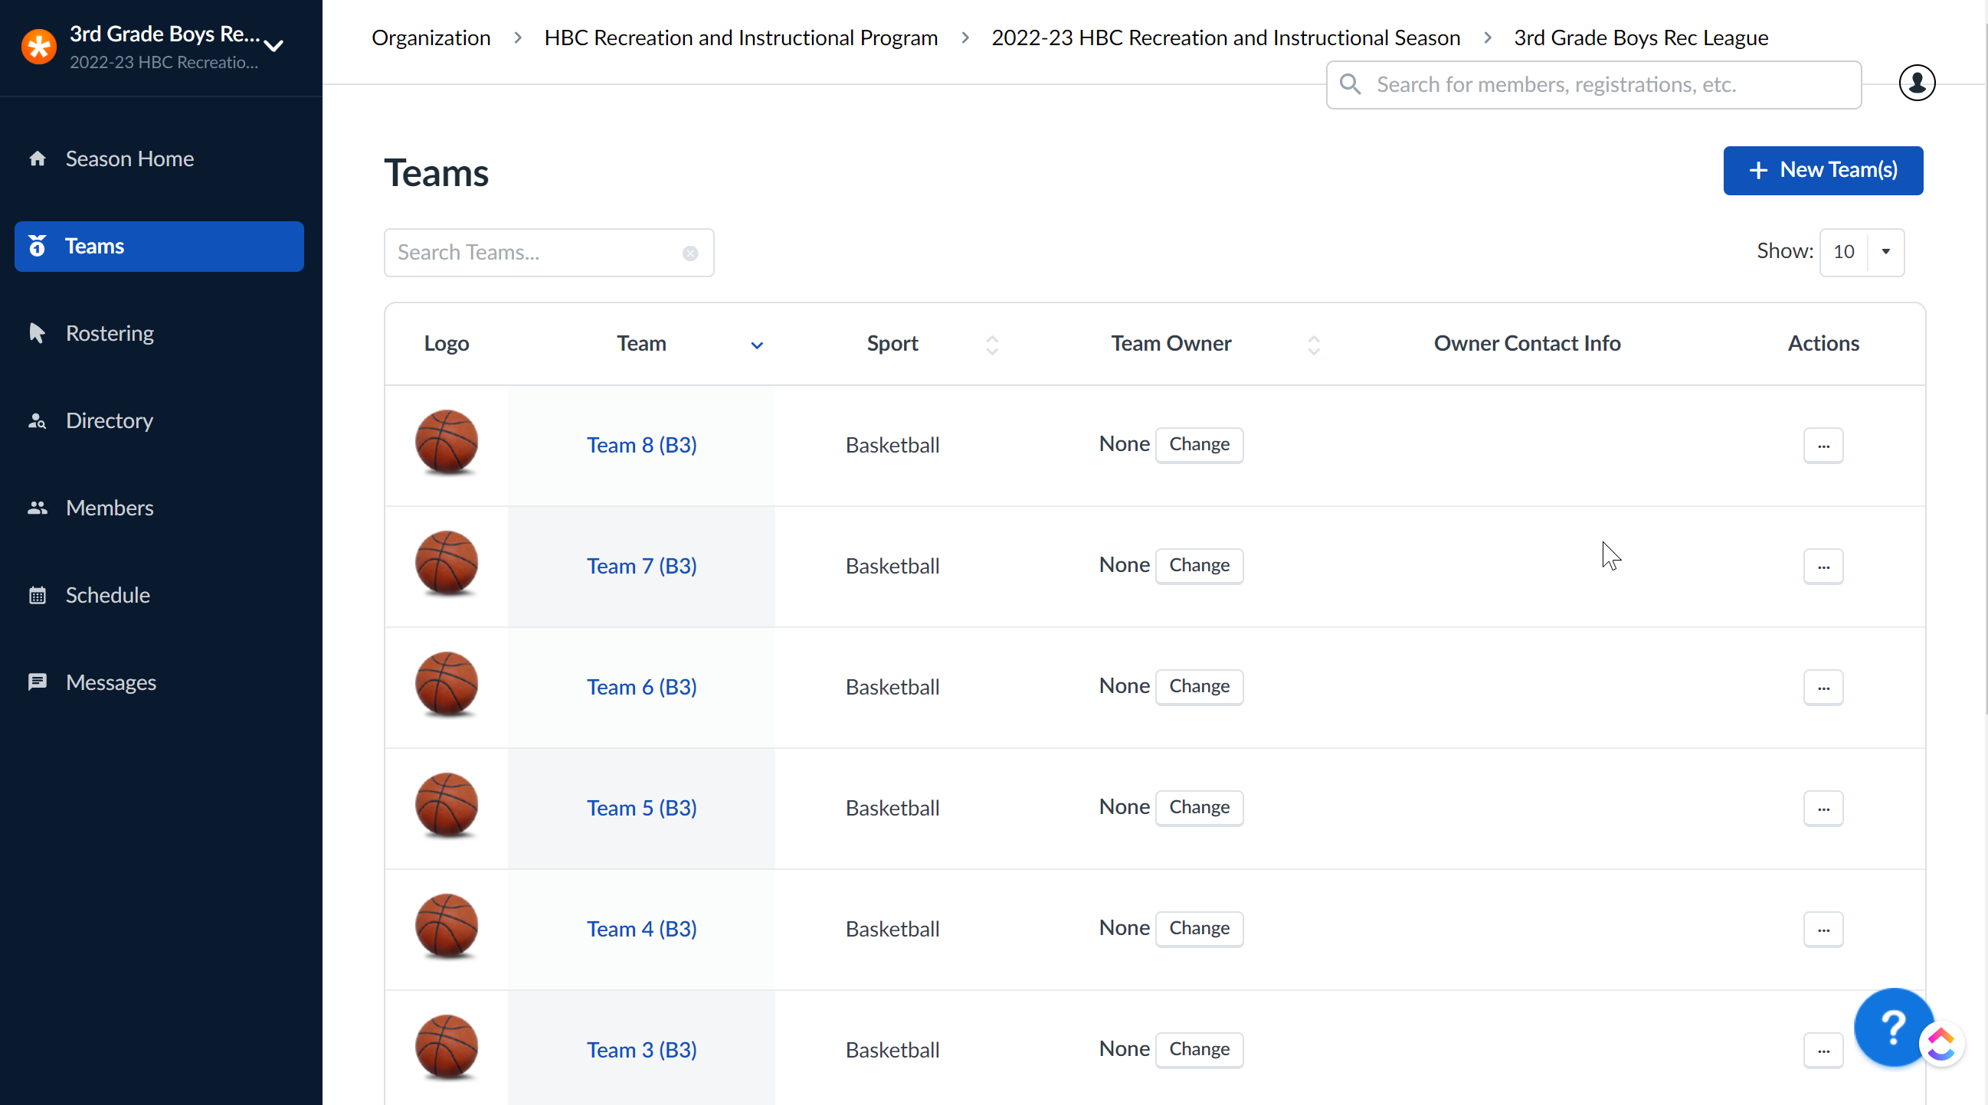
Enter Team Name – all other fields can be left blank for the time being.
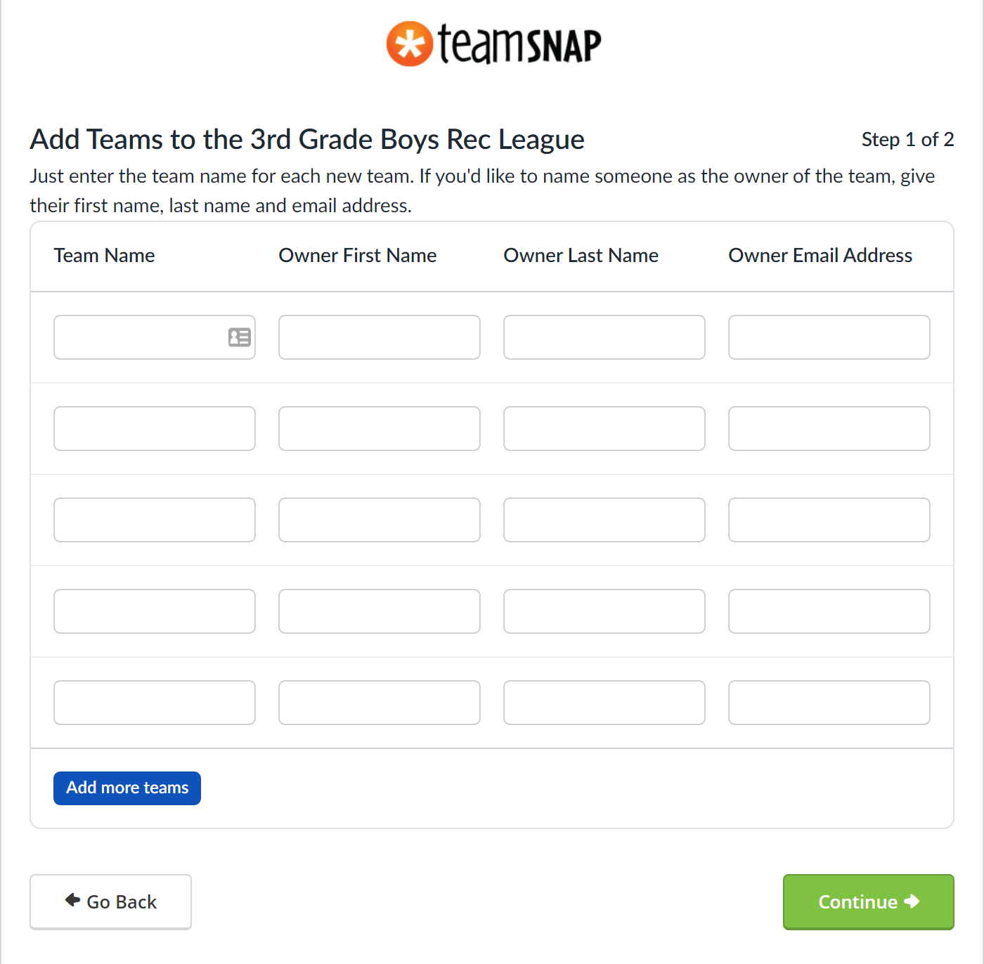
Step 2: (Optional) Export Division Roster of Players to Excel.
Navigate to the ‘Members’ tab and select the ‘Export Members’ button. You will receive an email with the exported data within a few minutes.
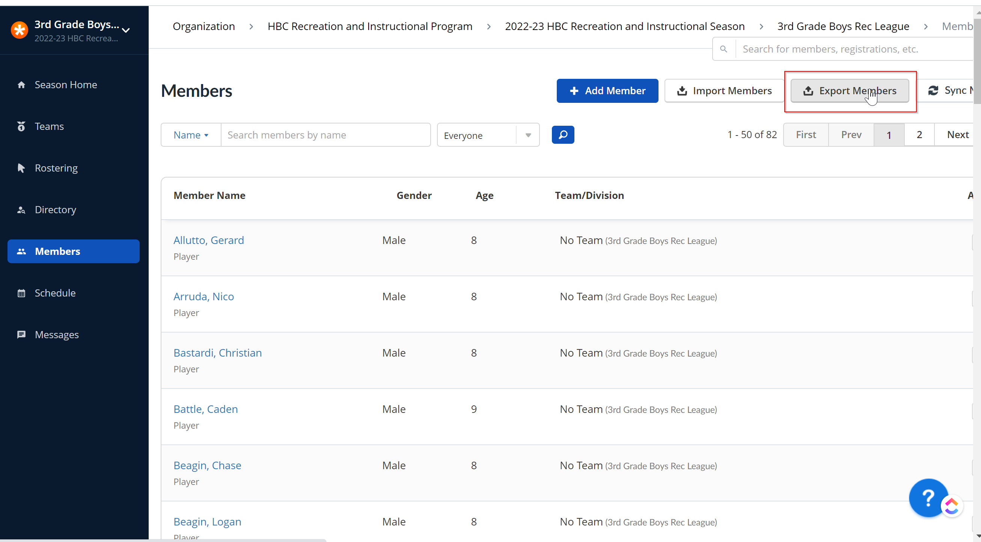

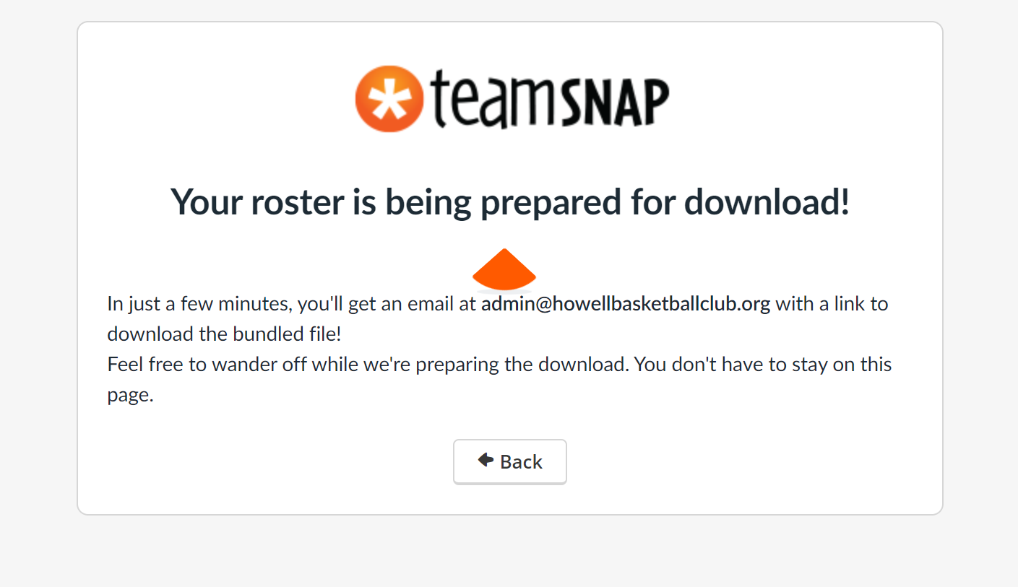
Step 3: Move Players from the Division Roster to the appropriate Team Roster.
Reference Link: Assigning Members to a Division or Team
Navigate to the ‘Rostering’ tab. You can add a filter be selecting from available fields and values if you wish to subset the list of Players. NOTE: As long as you are within your assigned Division (visible in upper left corner of the window) you should only see players that have been moved to your Division in the Player List.
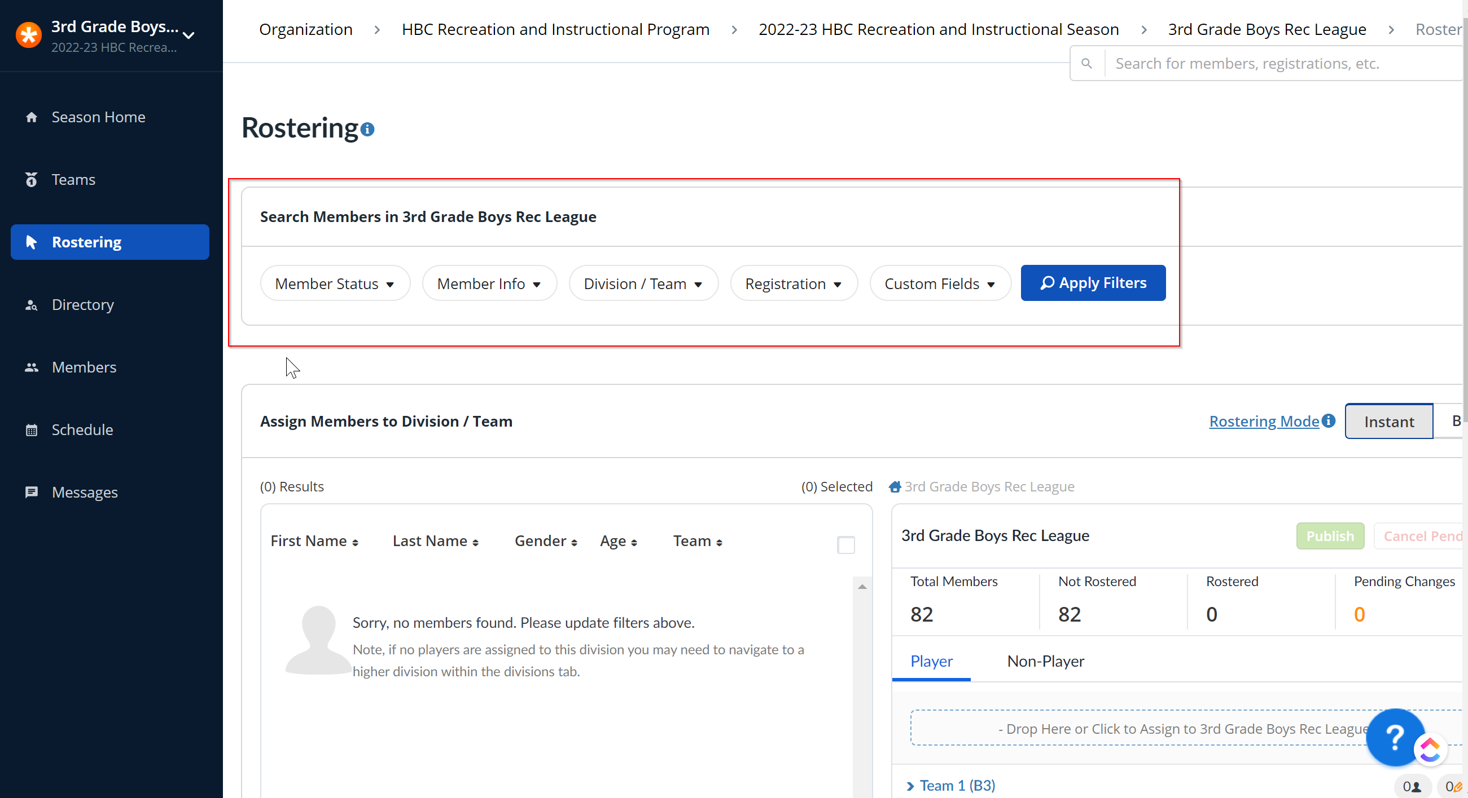

Page down on the ‘Rostering’ tab passed the filter section. You will see a list of all ‘Unassigned’ players (no Team assigned) in the left column and a list of available Teams within your Division in the right column.

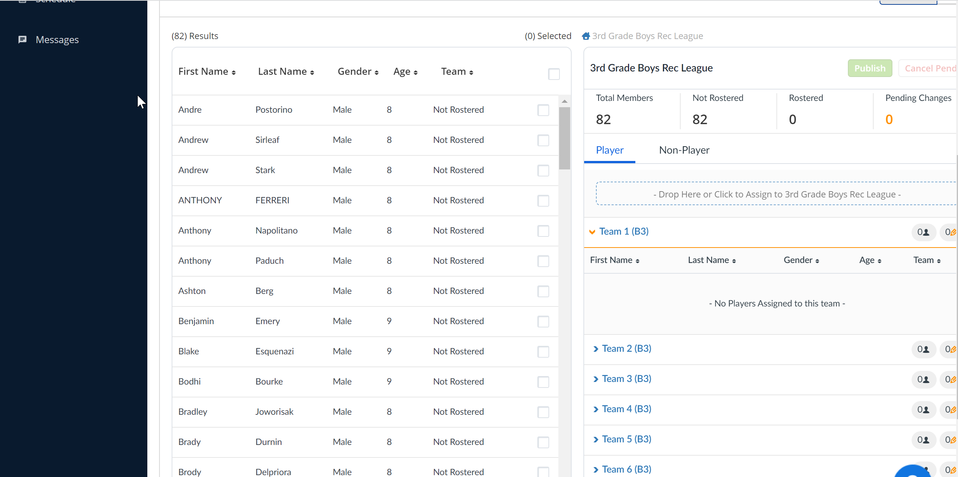

You can click on one or more players in the left column that you want to assign to a specific team. Once the players are selected, you will drag and drop those player(s) to the desired team in the right column. NOTE: In order to drop Players on to a specific Team, you must click on the Team Name to ‘expand’ the list of Players already on that team. Then you will be able to drop additional players on to that Team’s Roster.
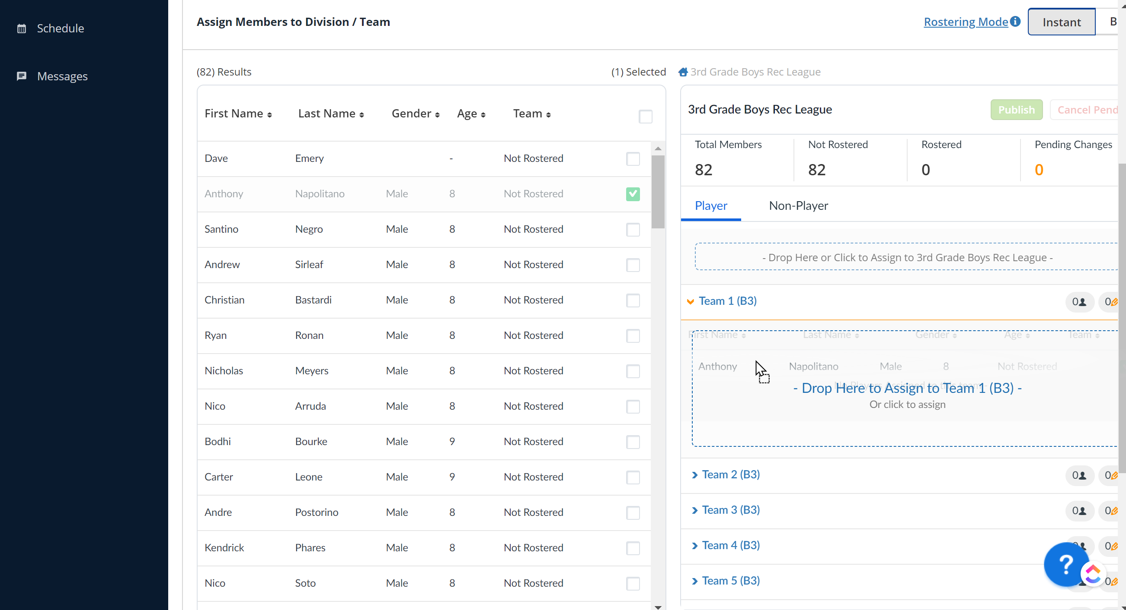

Step 4: Add Coaches to Team Rosters
Reference Link: Add and invite roster members
Once you select your Coaches, you will need to add those individuals directly to their assigned team by doing the following:
- Navigate to the ‘Teams’ tab within your Division
- Selecting the specific team that the new member will be coach
- Click on the Roster tab and click the ‘Add Player’ button.
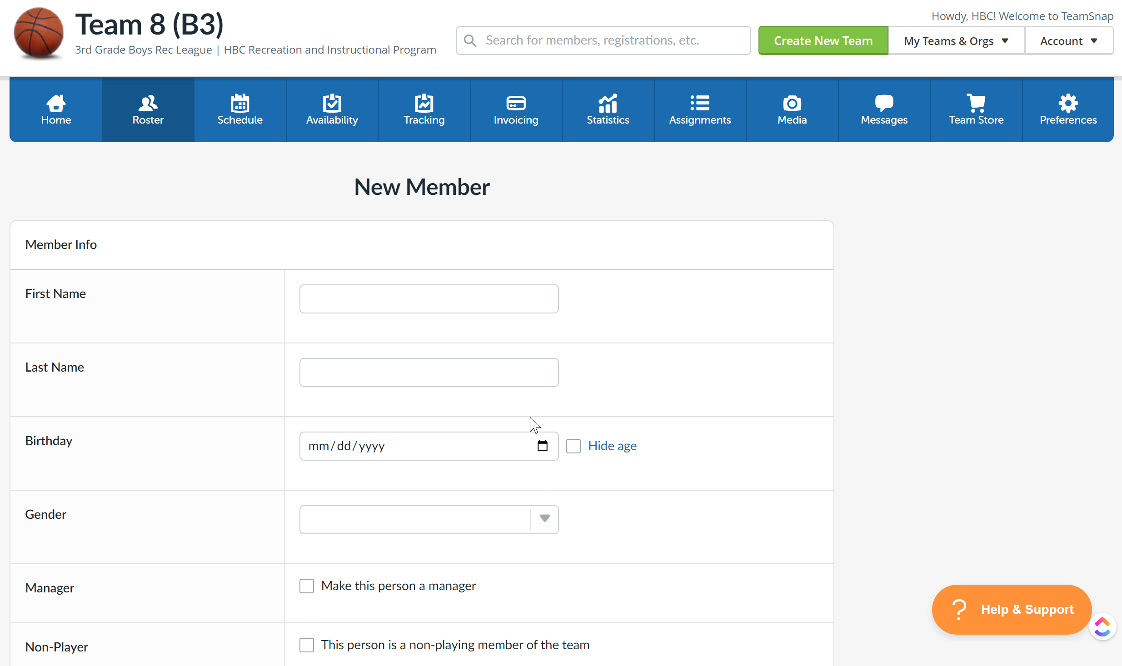

You will need to fill in First Name, Last Name, and Email Address as a minimal set of info to add the Coach. You will also need to find the Manager field and activate the check box to ‘Make this person a manager’ and similarly activate the check box next to the ‘This person is a non-playing member of the team.’
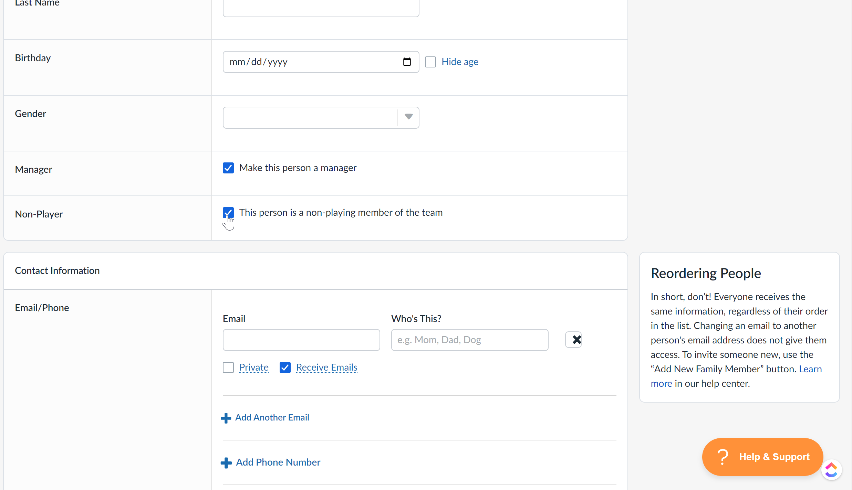
Step 5: Use the spreadsheet template to create the Season schedule for your Division. Import the resulting CSV file.
Importing schedules from a file
You can download the template pre-populated with ‘Division’ and ‘Location’ data from the HBC website at TeamSnap-SportsOrg-Schedule-Import-Template-Sheet.xlsx. Note that the posted file is an .xlsx (Excel) file. However, you will need to ‘Save as’ a .CSV (Comma delimited) file before you can import in to TeamSnap.
The ‘New Game’ and ‘Add Event’ buttons on the ‘Schedule’ tab can be used to manually enter Games or Events (e.g. practices), but this is time consuming.
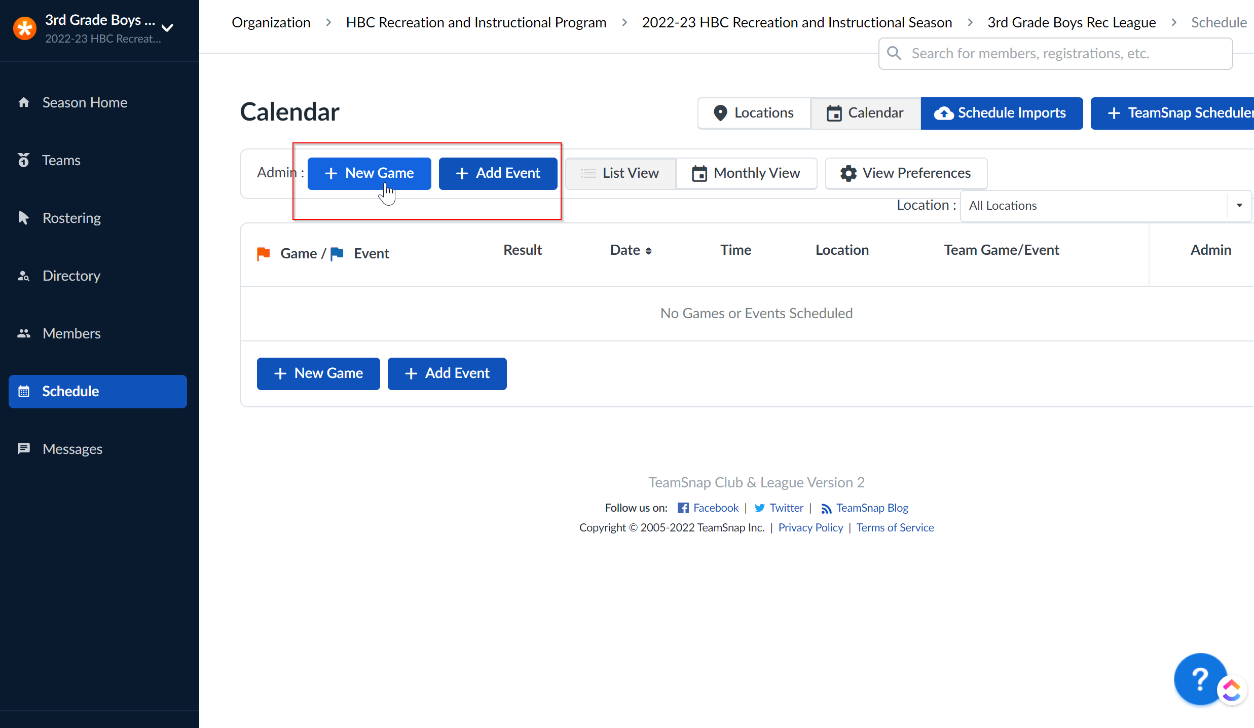

The ‘Schedule Imports’ button can be used to import your entire season schedule into the system in one shot. You must first ‘Upload Import File’ to get the file on to the server. You then have to take a second step to ‘Upload Schedule from File’ to load the content of that file into the TeamSnap Schedule function.

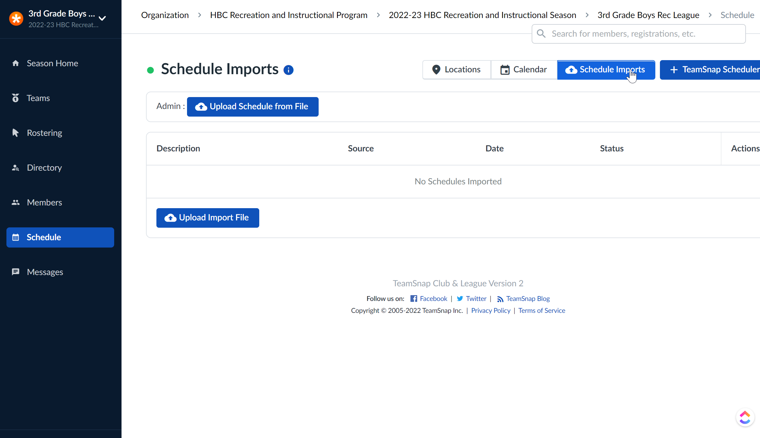

Step 6: Use the ‘Messages’ function to communicate with you entire Division, only the Coaches in the Division, or the members of a specific Team as needed.
At the League/Division level, the only option you have within the Messages tab is to send emails. Text Messages are only available down at the ‘Team’ Level.
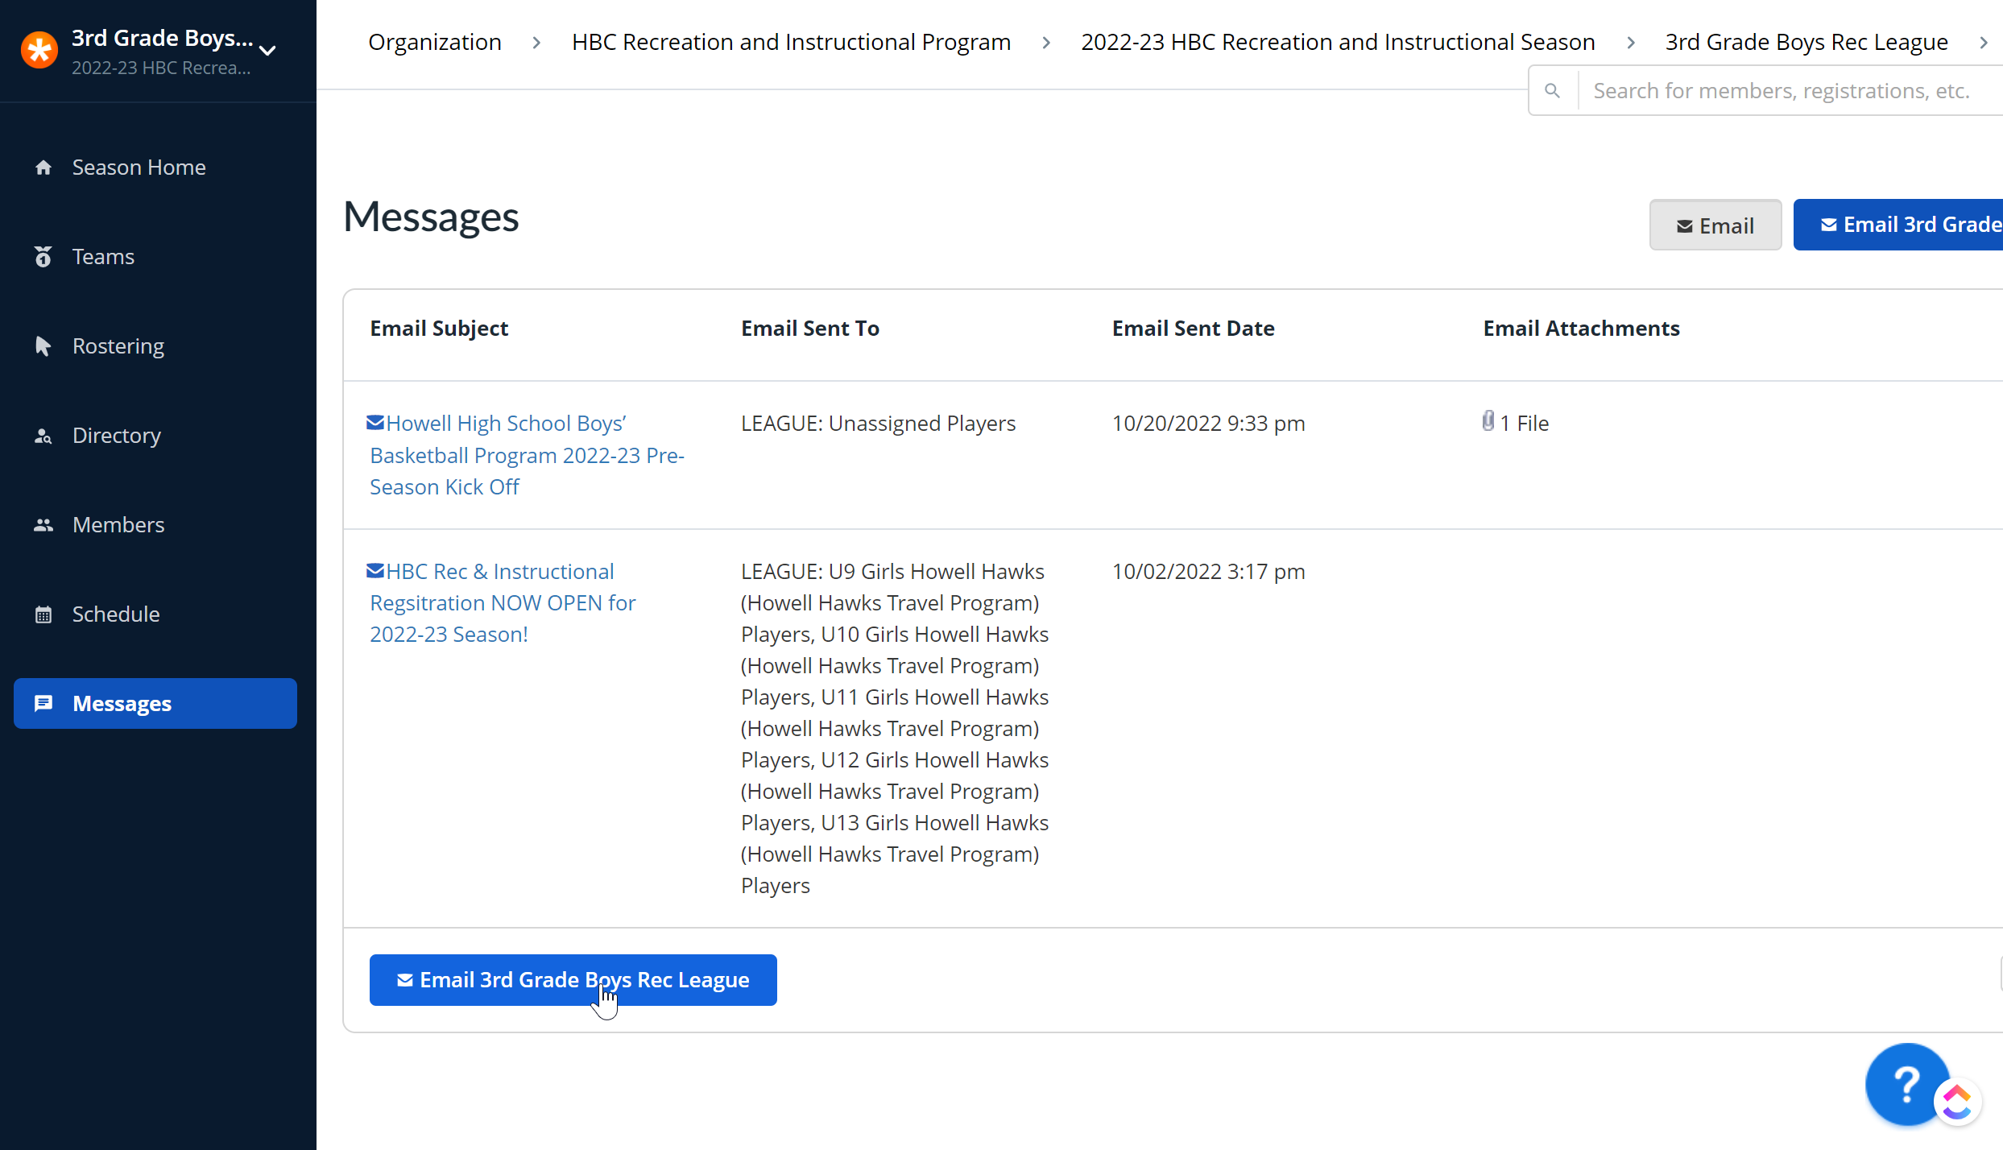

You first enter the Subject and Body of the message to be sent in the email editor.
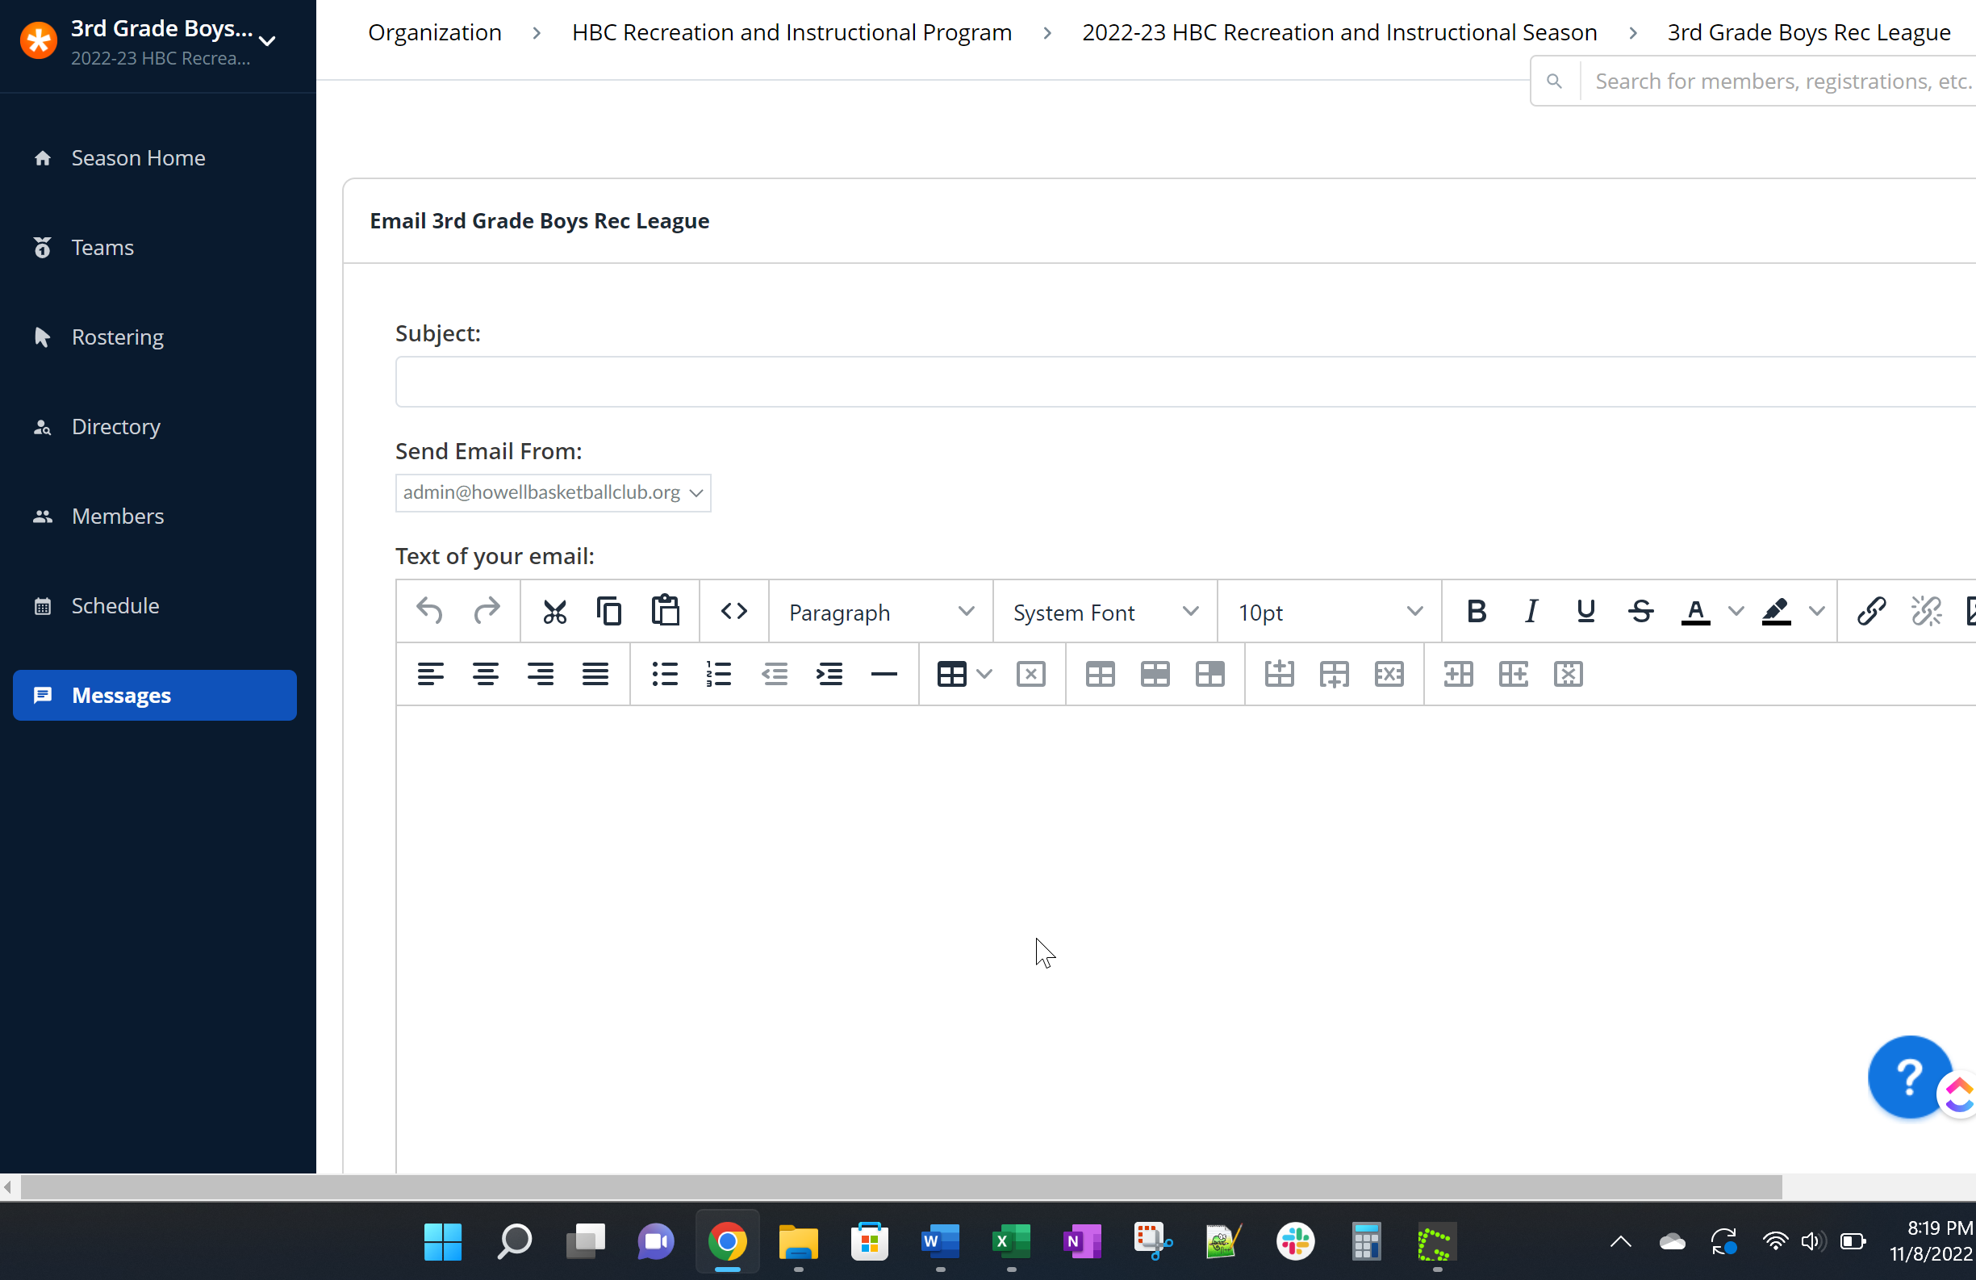

You then select Players and/or Managers you want this message to be sent to. You have the option to add File attachments and you can have the system send a copy of your email to your email account as well.
